EXPERIMENT 9

15BCE0517

M.S.SANJAY

**1) Null Hypothesis- H0 : Preference for ice-cream is independent of gender**

**Alternate Hypothesis- H1 : Preference for ice-cream depends of gender**

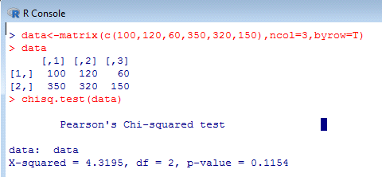

**Interpretation:-**

**Here p-value=0.1154 is greater than 0.05. Hence we accept the null hypothesis and conclude that there is no association between gender and preference of ice-cream**

**2)**

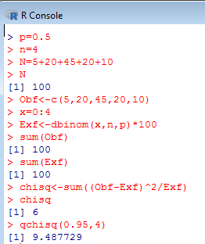

**Inference: Calculated value of chi-square is less than tabulated values, it is not significant at 5% level and hence the null hypothesis holds.**